**SWE 557**

**Artificial Intelligence and Machine Learning**

*Face Recognition*

*(Comparing Logistic, SVM and Naive Bayes algorithms)*



Project Supervisor - Prof. John Kim

**Project by:**

1. **Savita Khadse - 27565948**
2. **Samee Peerzade - *59638609***

**Acknowledgement**

We take this opportunity to thank Professor John Kim, International Technological University, Santa Clara for the valuable support and guidance extended to us, which helped in the successful completion of the project.

**Table of Content**

| S No | Topic | Page No |
| --- | --- | --- |
| 1 | **Objective** | 3 |
| 2 | **Abstract** | 4 |
| 3 | **Introduction: What is Face recognition** | 5 |
| 4 | **Data set** | 6 |
| 5 | **Libraries imported** | 7-10 |
| 6 | **Algorithms Used** | 11-17 |
| 7 | **Project Flow/Steps** | 18-21 |
| 8 | **Framework for Face recognition system** | 22 |
| 9 | **Conclusion** | 23 |
| 10 | **References** | 24 |

**Objective**

**Face recognition technology is used to find a series of data of the same face in a set of training images in a database from the incoming image.**

**The findings of this work would be useful for identification of a suitable machine-learning algorithm out of Logistic, Support Vector Machine and Naive Bayes algorithms to achieve highest face recognition accuracy.**

**Abstract**

Face recognition has been a fast growing, challenging and interesting area in real time applications like social media platforms like facebook, Instagram, Twitter, Law enforcement agencies use it to identify suspects or track down missing persons, Tech companies use it to allow consumers to easily unlock their devices, security applications to authenticate users through ID verification services and many more….

A large number of face recognition algorithms have been developed in the last few decades. In this project an attempt is made to review a few methods/algorithms used for face recognition comprehensively. This includes PCA, Logistic regression, SVM and Naive Bayes.

Face recognition technology is capable of matching a human face from a digital image or a video frame against a database of faces. The objective of this work is to achieve better accuracy for face recognition by comparing the performance of Support Vector Machine(SVM), Naive Bayes and Logistic Regression algorithms. In this project, we will also be using Principal Component Analysis(PCA) for dimension reduction. We made sure that the performance of a face recognition system is determined by how to extract feature vectors exactly and classify them accurately. Principal Component Analysis plays a key role in feature extractor and SVM, Naive Bayes and Logistic regression algorithms are used to compare the accuracy of the face recognition problem.

This work will use a dataset from scikit learn (through command fetch_olivetti_faces()) to evaluate, experiment and strategies. This project concentrates on several sophisticated Python libraries like NumPy, Pandas and Matplotlib. The task will be carried out in the Anaconda Jupyter notebook/Colab. The findings of this work would be useful for identification of a suitable machine-learning algorithm out of Logistic, SVM and Naive Bayes algorithms to achieve better face recognition accuracy.

**Introduction**

Face recognition is one of the few biometric methods that possess the merits of both high accuracy and low intrusiveness. Numerous algorithms have been proposed for face recognition.

In general, a face recognition algorithm can be divided into the following functional modules: a **face image detector** finds the locations of human faces from a normal picture against simple or complex background, and a **face recognizer** determines who this person is by looking into the database. Both the face image detector and the face recognizer follow the same framework; they both have a feature extractor that transforms the pixels of the facial image into a useful vector representation, and a pattern recognizer that searches the database to find the best match to the incoming face image. In the face recognition scenario, on the other hand, the recognizer classifies the feature vector (assuming it is from a “face” image) as “Maria’s face”, “Monk’s face” or someone else’s face that is already registered in the database.

During the past decades, face recognition has received increased attention and has advanced technically. Recently, significant research efforts have been focused on video-based face modeling/tracking, recognition and system integration. New databases have been created and evaluations of recognition techniques using these databases have been carried out. Now, face recognition has become one of the most active applications of pattern recognition, image analysis and understanding. So, continuous research in best suitable algorithms will go a long way.

**Data Set**

The data set is imported from sklearn <https://scikit-learn.org/> document through function fetch_olivettii_faces() and it has following characteristics:

* There are ten different image of each of 40 distinct people
* There are 400 face images in the dataset
* Face images were taken at different times, varying lighting, facial express and facial detail
* All face images have black background
* The images are gray level
* Size of each image is 64x64
* Dimensionality is 4096
* Image pixel values were scaled to [0, 1] interval
* Names of 40 people were encoded to an integer from 0 to 39

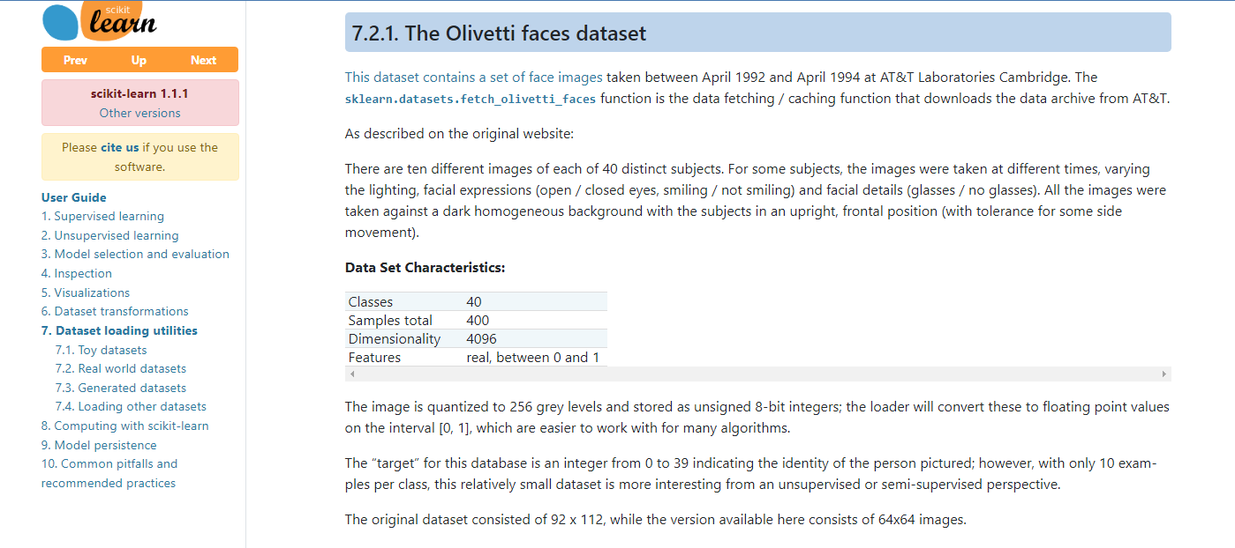

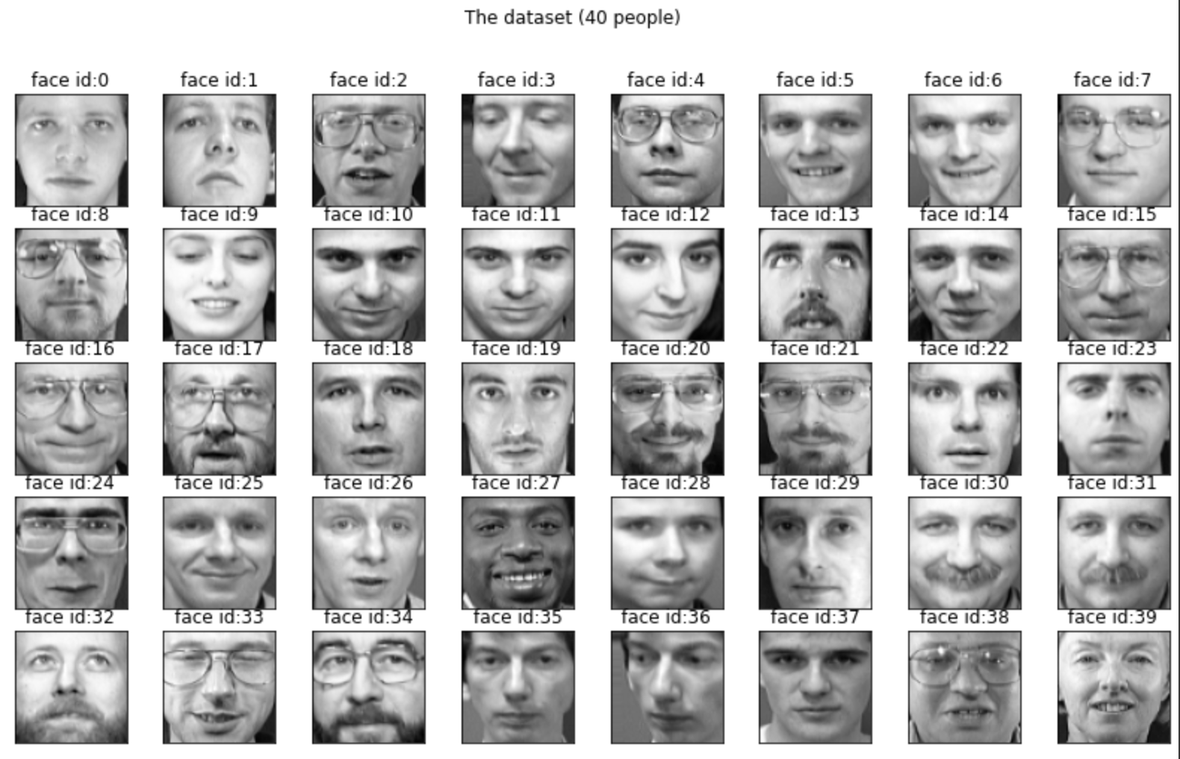

**Libraries**

**Numpy**

NumPy is a general-purpose array-processing package. It provides a high-performance multidimensional array object, and tools for working with these arrays. It is the fundamental package for scientific computing with Python. It is open-source software. It contains various features including these important ones:

* A powerful N-dimensional array object
* Sophisticated (broadcasting) functions
* Tools for integrating C/C++ and Fortran code
* Useful linear algebra, Fourier transform, and random number capabilities

**Pandas**

Pandas is a [software library](https://en.wikipedia.org/wiki/Software_library) written for the [Python programming language](https://en.wikipedia.org/wiki/Python_(programming_language)) for data manipulation and [analysis](https://en.wikipedia.org/wiki/Data_analysis).[[2]](https://en.wikipedia.org/wiki/Pandas_(software)#cite_note-2) In particular, it offers [data structures](https://en.wikipedia.org/wiki/Data_structure) and operations for manipulating numerical tables and [time series](https://en.wikipedia.org/wiki/Time_series). It is [free software](https://en.wikipedia.org/wiki/Free_software) released under the [three-clause BSD license](https://en.wikipedia.org/wiki/3-clause_BSD_license). The name is derived from the term "[panel data](https://en.wikipedia.org/wiki/Panel_data)", an [econometrics](https://en.wikipedia.org/wiki/Econometrics) term for [data sets](https://en.wikipedia.org/wiki/Data_set) that include observations over multiple time periods for the same individuals.[[4]](https://en.wikipedia.org/wiki/Pandas_(software)#cite_note-4) Its name is a play on the phrase "Python data analysis" itself.[[5]](https://en.wikipedia.org/wiki/Pandas_(software)#cite_note-5)

* DataFrame [object](https://en.wikipedia.org/wiki/Object-oriented_programming) for data manipulation with integrated indexing.
* Tools for reading and writing data between in-memory [data structures](https://en.wikipedia.org/wiki/Data_structure) and different [file formats](https://en.wikipedia.org/wiki/File_format).
* Data alignment and integrated handling of missing data.
* Reshaping and pivoting of data sets.
* Label-based slicing, fancy indexing, and subsetting of large data sets.
* Data structure column insertion and deletion.
* **Group by engine allowing split-apply-combine operations on data sets.**
* **Data set merging and joining.**
* **Hierarchical axis indexing to work with high-dimensional data in a lower-dimensional data structure.**
* **Time series-functionality: Date range generation**[**[7]**](https://en.wikipedia.org/wiki/Pandas_(software)#cite_note-7) **and frequency conversions, moving window** [**statistics**](https://en.wikipedia.org/wiki/Statistics)**, moving window** [**linear regressions**](https://en.wikipedia.org/wiki/Linear_regression)**, date shifting and lagging.**
* **Provides data filtration.**

**Matplotlib**

Matplotlib is a cross-platform, data visualization and graphical plotting library for Python and its numerical extension is NumPy. As such, it offers a viable open source alternative to MATLAB. Developers can also use matplotlib’s APIs (Application Programming Interfaces) to embed plots in GUI applications.

A Python matplotlib script is structured so that a few lines of code are all that is required in most instances to generate a visual data plot. The matplotlib scripting layer overlays two APIs:

* The pyplot API is a hierarchy of Python code objects topped by *matplotlib.pyplot*
* An OO (Object-Oriented) API collection of objects that can be assembled with greater flexibility than pyplot. This API provides direct access to Matplotlib’s backend layers.

### **Matplotlib and Pyplot in Python**

The pyplot API has a convenient MATLAB-style stateful interface. In fact, matplotlib was originally written as an open source alternative for MATLAB. The OO API and its interface is more customizable and powerful than pyplot, but considered more difficult to use. As a result, the pyplot interface is more commonly used, and is referred to by default in this article.

Understanding matplotlib’s pyplot API is key to understanding how to work with plots:

* *matplotlib.pyplot.figure: Figure* is the top-level container. It includes everything visualized in a plot including one or more *Axes*.
* *matplotlib.pyplot.axes: Axes* contain most of the elements in a plot: *Axis, Tick, Line2D, Text,* etc., and sets the coordinates. It is the area in which data is plotted. Axes include the X-Axis, Y-Axis, and possibly a Z-Axis, as well.



**Algorithms**

Machine Learning algorithms are categorized as below:

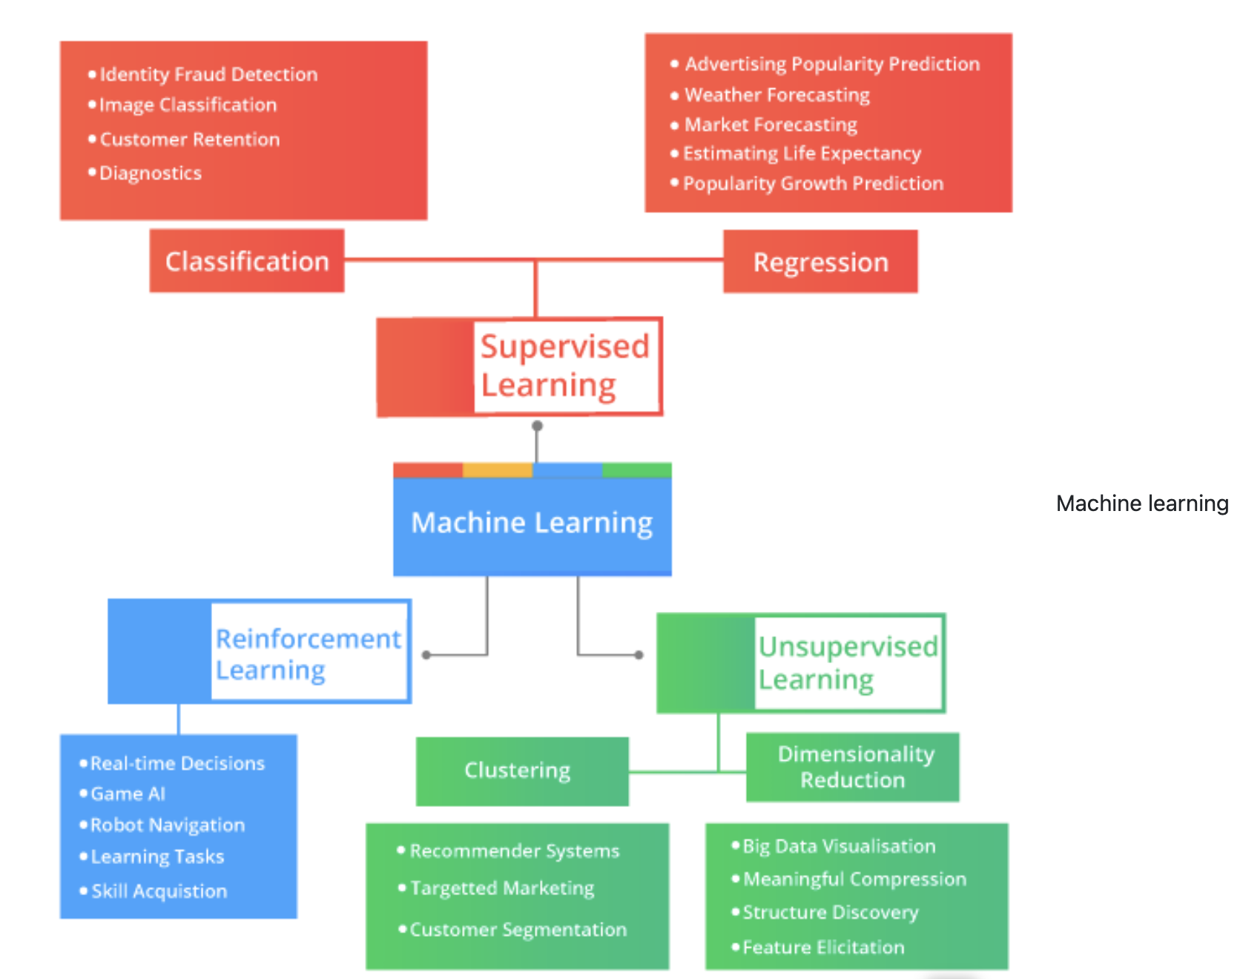

**How to select algorithm depends on your problem statement**

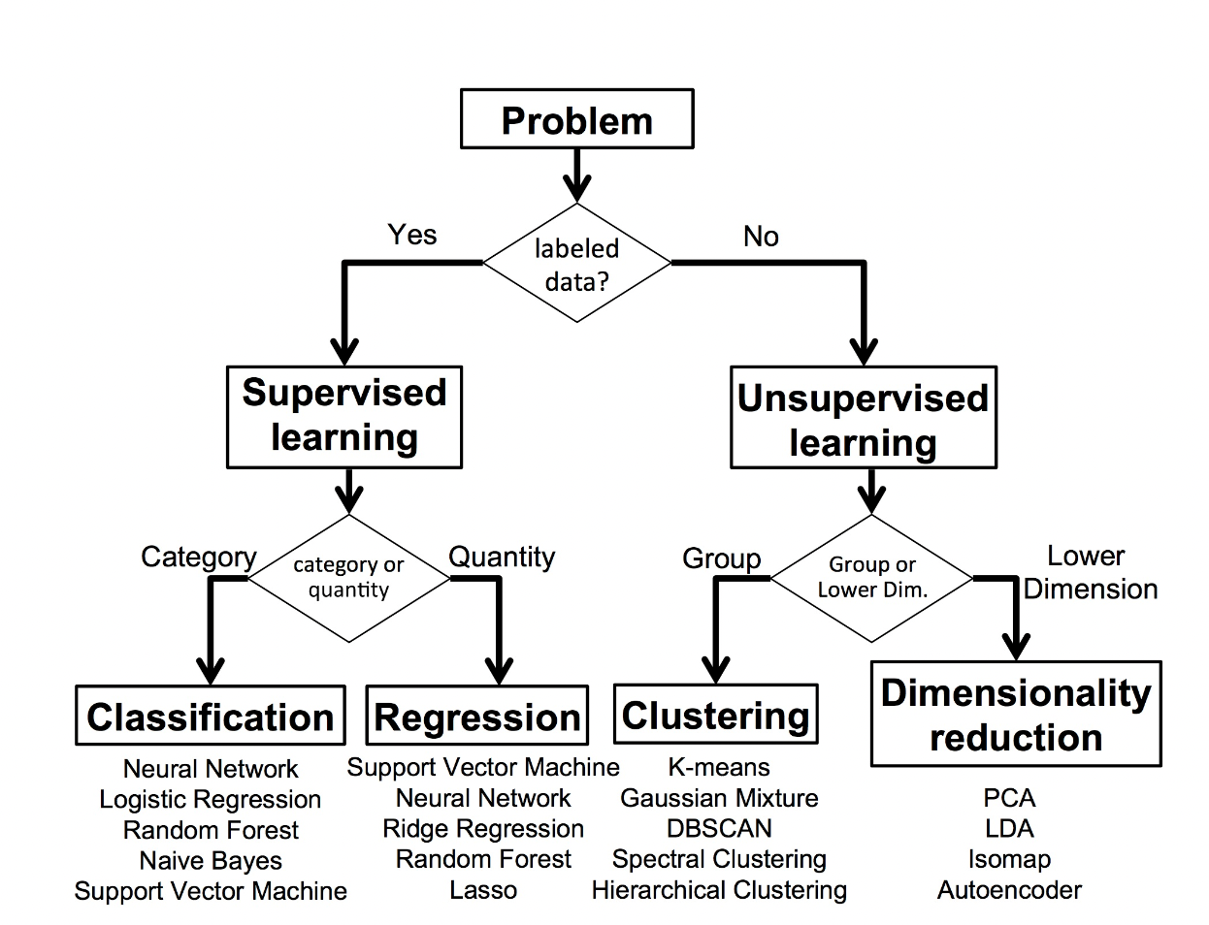

**Visualization of algorithms output:**

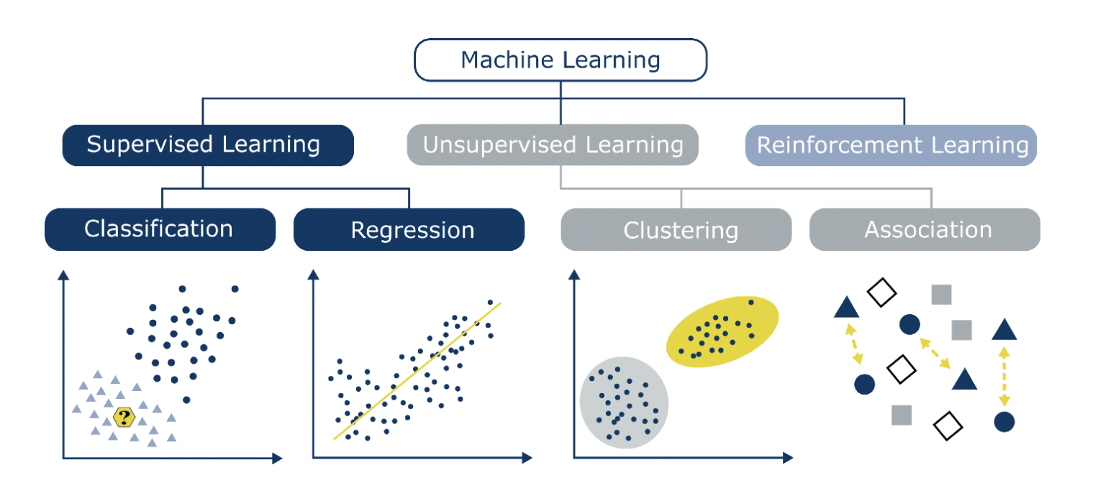

**For this project we will be working on Supervised-classification and PCA as shown in below chart:**

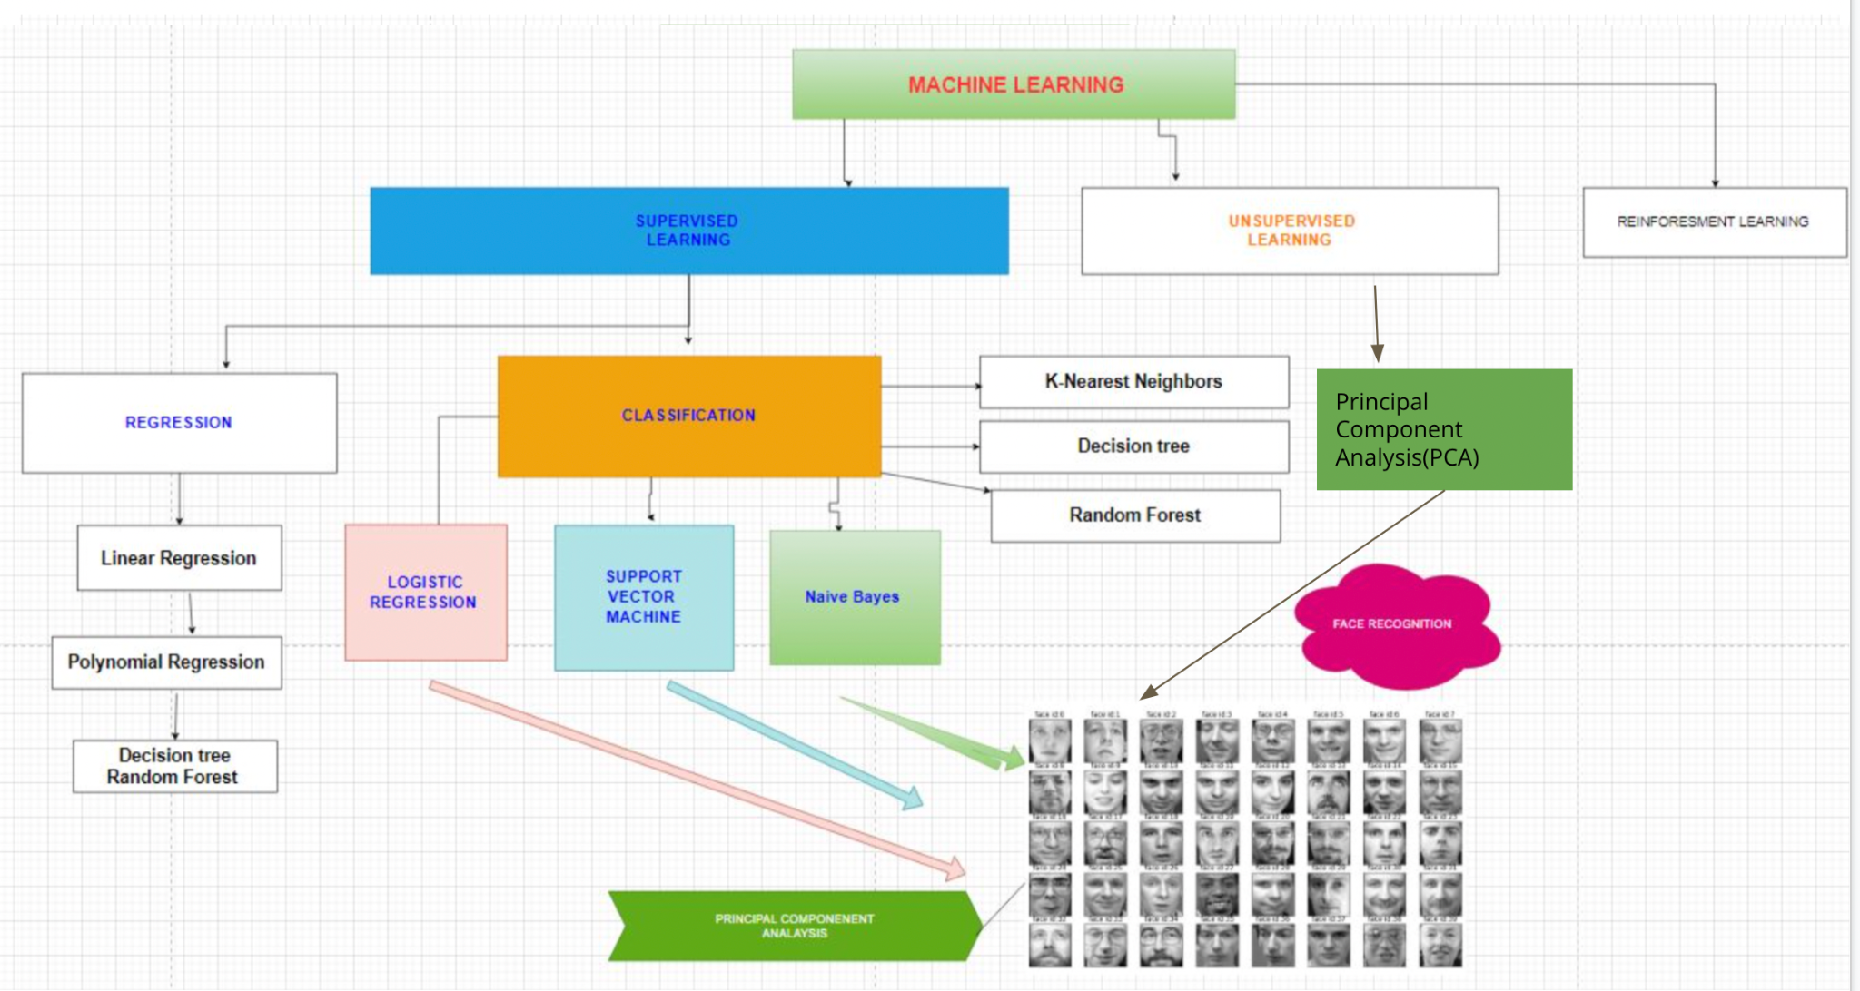

**Logistic regression** algorithm is the simplest classification algorithm used for binary or multi-classification problems. Using linear regression we cannot divide outcome into categories. In such cases we can use Classification algorithms. For example using logistic regression and sigmoid function we can show data of students marks vs hours of study as below:

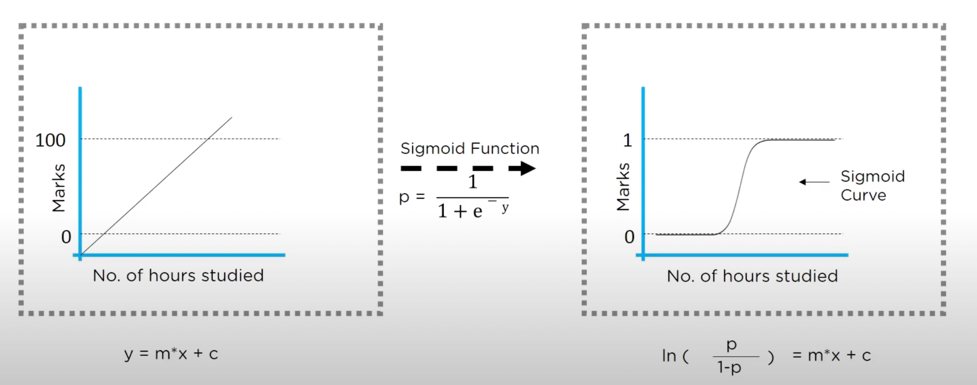In this example, in the first graph we have linear regression where we can determine marks will increase as hours of study increases but to decide if a student fails or passes using this data we need to use sigmoid function. 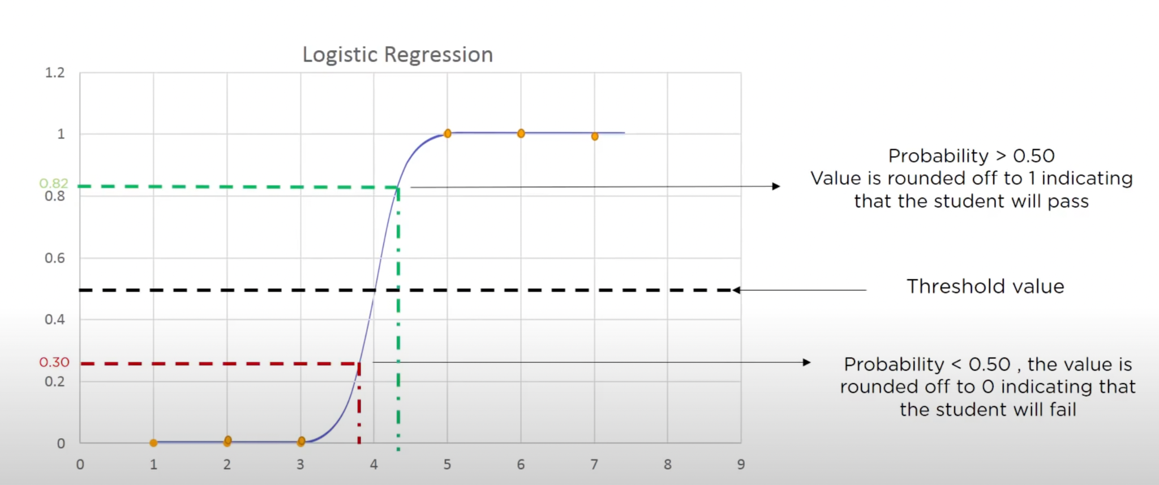

**Support vector Machine** is a supervised learning method that looks at data and sorts it into two categories using a hyperplane. It is the most popular algorithm for classification in Machine learning algorithms.

The mathematical background is quintessential in building the foundational block for the geometrical distinction between the two classes. While they can be used for regression, SVM is mostly used for classification. 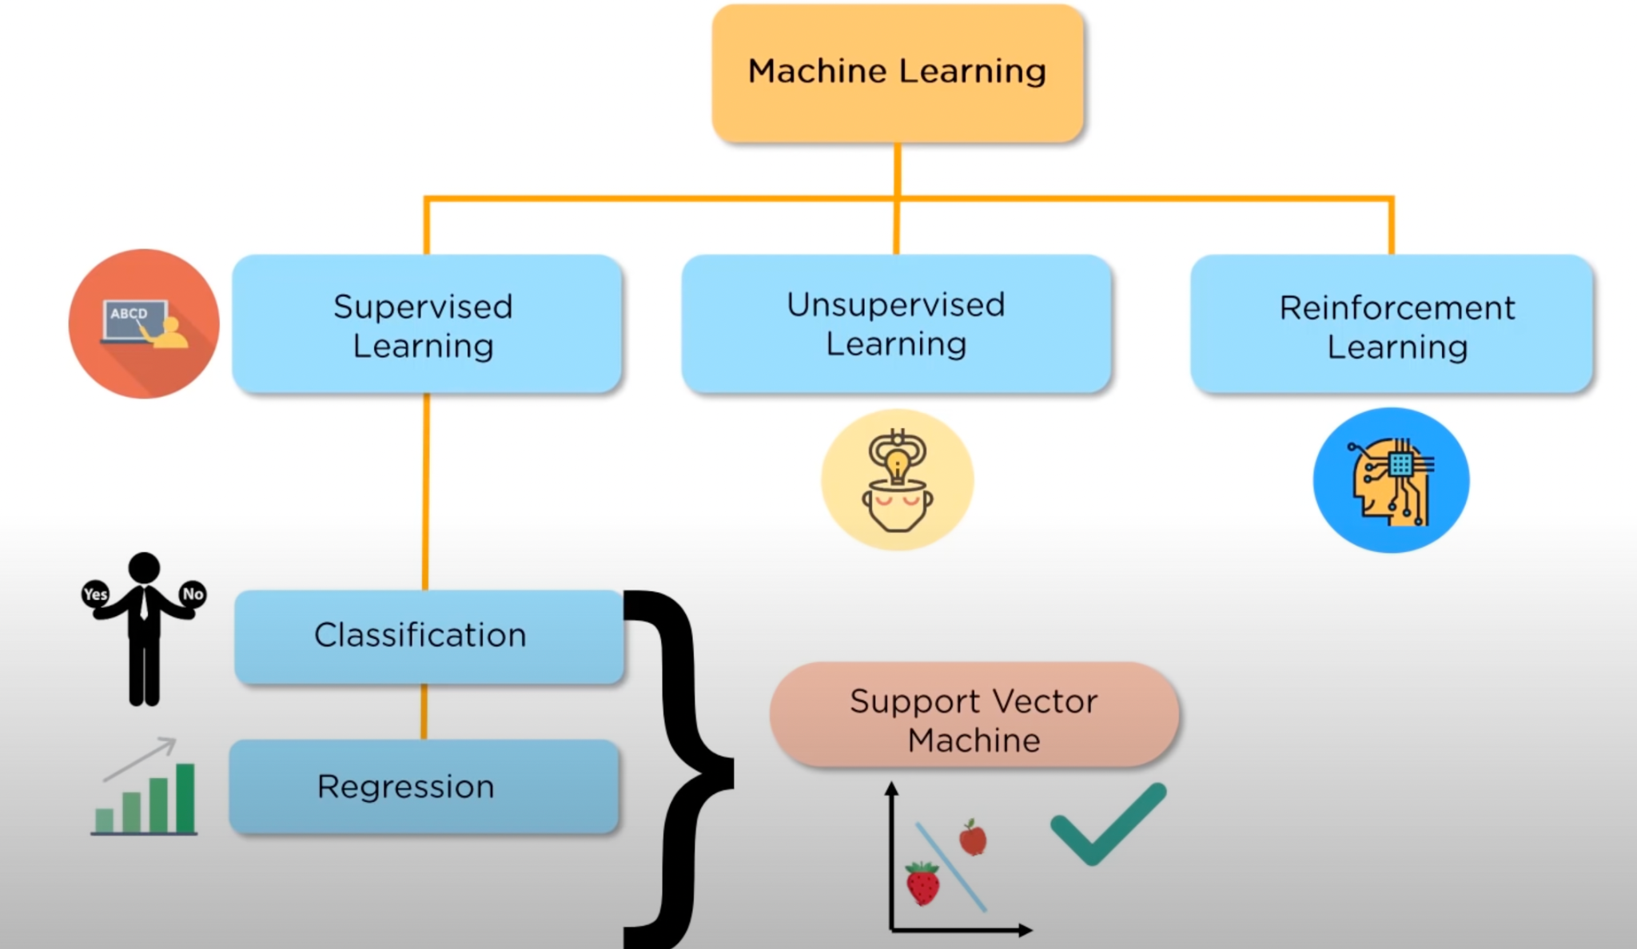

The basic principle behind the working of Support vector machines is simple – Create a hyperplane that separates the dataset into classes. We have to find the points from the dataset that lies closest to both the classes. These points are known as **support vectors**(R1, R2 and G1). The distance between the points and the dividing line is known as **margin**. The aim of an SVM algorithm is to maximize this very margin. When the margin reaches its maximum, the hyperplane becomes the optimal one.

Once we create an optimal hyperplane we can easily predict on which side our new data fits in. SVM also helps in curse of dimensionality, where we need to decide a hyperplane based on a huge amount of support vectors. Also, Regularization parameter or lamda helps in overfitting and underfitting problems.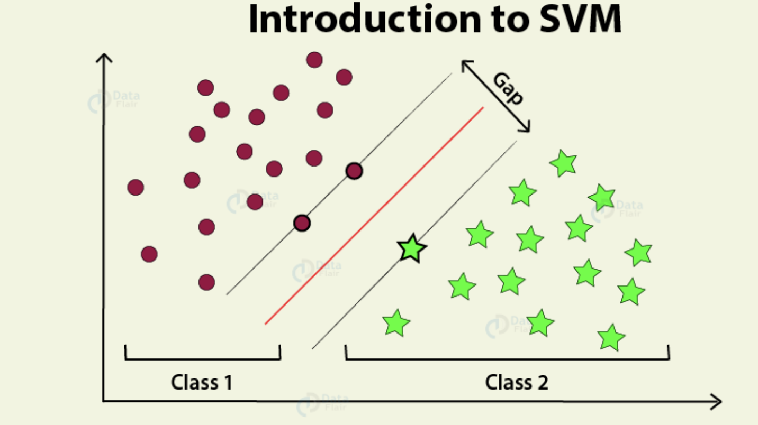Note: **We have seen examples of 2D data previously but when our data is in 1D we need a kernel to convert data from 1D to 2D and 3D.** 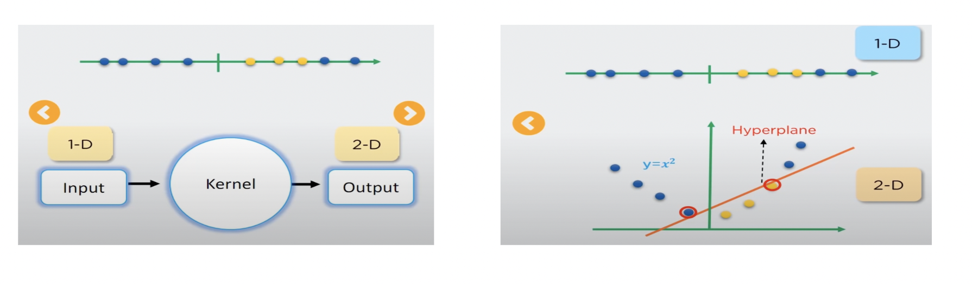

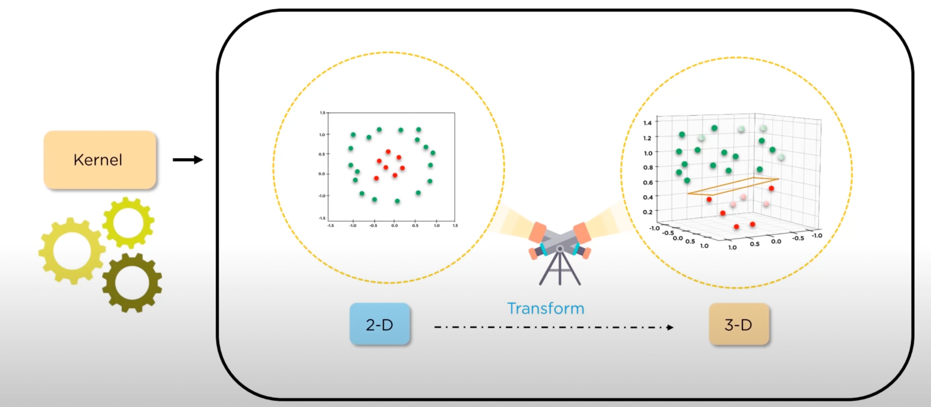

**Naive Bayes** is one of the powerful machine learning algorithms that is used for classification which helps in building the fast machine learning models which will make quick predictions. It works on the principles of conditional probability as given by the “Bayes Theorem”.

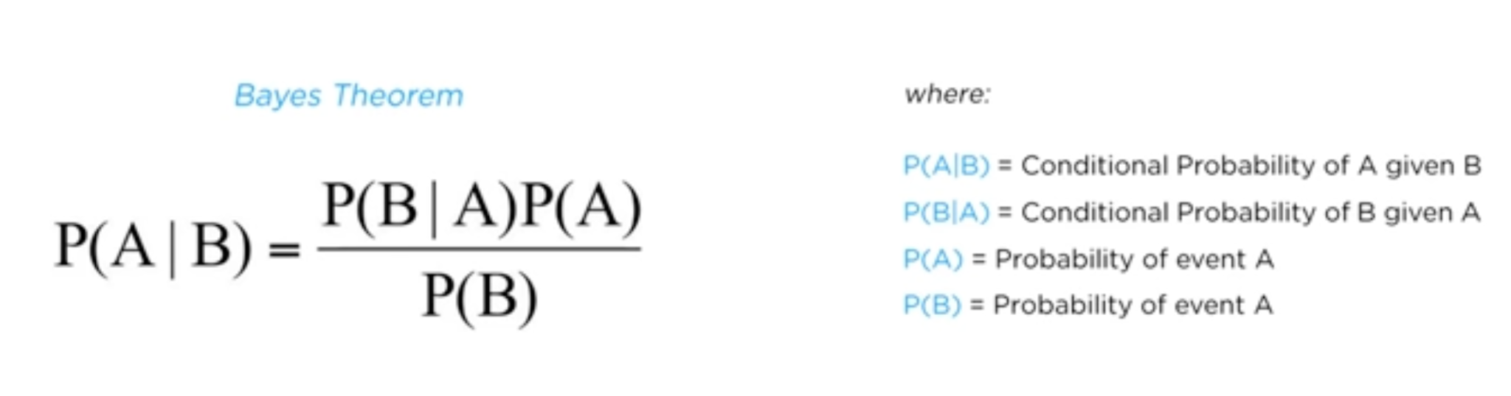

Naive Bayes algorithm is useful for:

* Naive Bayes is an easy and quick way to predict the class of the dataset. Using this, one can perform a multi-class prediction.
* When the assumption of independence is valid, Naive Bayes is much more capable than the other algorithms like logistic regression.
* Furthermore, you will require less training data.

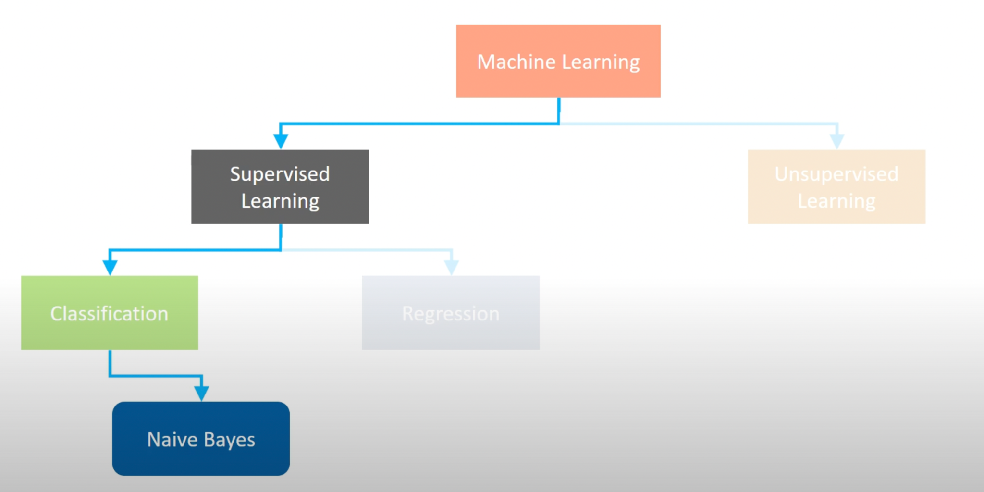

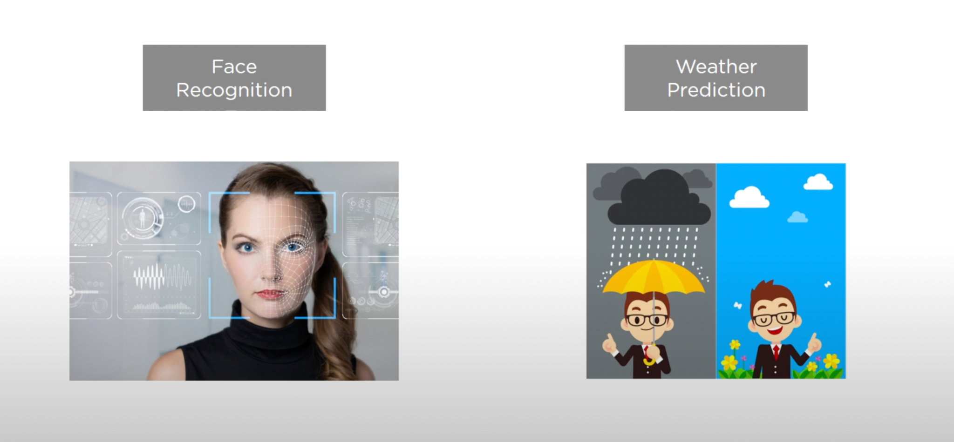

Naive Bayes methods are a set of supervised learning algorithms based on applying Bayes’ theorem with the “naive” assumption of conditional independence between every pair of features given the value of the class variable.

* [Gaussian Naive Bayes](https://scikit-learn.org/stable/modules/naive_bayes.html#gaussian-naive-bayes)
* [Multinomial Naive Bayes](https://scikit-learn.org/stable/modules/naive_bayes.html#multinomial-naive-bayes)
* [Complement Naive Bayes](https://scikit-learn.org/stable/modules/naive_bayes.html#complement-naive-bayes)
* [Bernoulli Naive Bayes](https://scikit-learn.org/stable/modules/naive_bayes.html#bernoulli-naive-bayes)
* [Categorical Naive Bayes](https://scikit-learn.org/stable/modules/naive_bayes.html#categorical-naive-bayes)
* [Out-of-core naive Bayes](https://scikit-learn.org/stable/modules/naive_bayes.html#out-of-core-naive-bayes-model-fitting)

**Gaussian Naive Bayes**

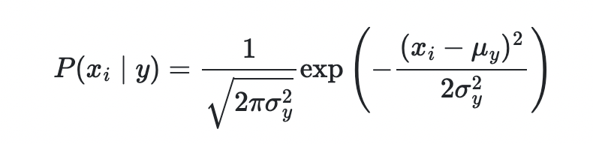

***Principal Component Analysis (PCA)***

**What is PCA?**

Principal Component Analysis (PCA) is a dimensionality reduction technique that enables you to identify correlations and patterns in a data set so that it can be transformed into a data set of significantly lower dimension(Principal Components) without loss of any important information.

**Why do we need PCA?**

High dimension data is extremely complex to process due to inconsistencies in the features which increase the computation time and make data processing and EDA more convoluted.

***Reducing*** the ***dimension*** of the feature space is called “***dimensionality reduction***.”

Dimensionality reduction technique can be used to filter only a limited significant features which are needed for training your model or predictive model or ML.

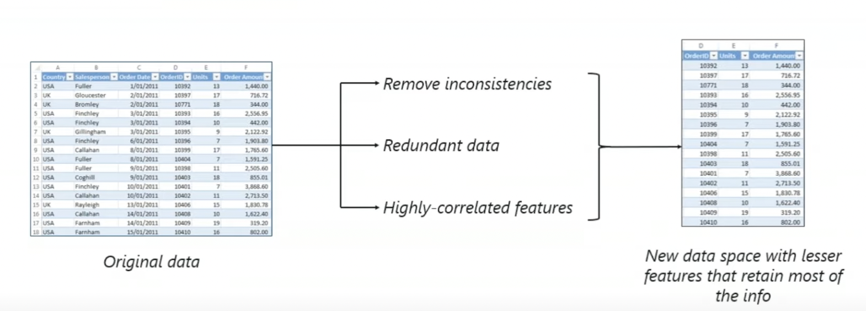

Principal component analysis is a technique for *feature extraction* — so it combines our input variables in a specific way, then we can drop the “least important” variables while still retaining the most valuable parts of all of the variables! *As an added benefit, each of the “new” variables after PCA are all independent of one another.*

This is a benefit because the assumptions of a linear model require our independent variables to be independent of one another.

You should have tabular data organized with *n* rows and likely *p+1* columns, where one column corresponds to your dependent variable (usually denoted ***Y***) and *p* columns where each corresponds to an independent variable (the matrix of which is usually denoted ***X***).

Process of obtaining principal components from a raw dataset can be simplified in six parts :

1. Take the whole dataset consisting of *d+1 dimensions* and ignore the labels such that our new dataset becomes *d dimensional. Normally, X_train + y_train makes up our complete train dataset. Where X_train is d and 1 is y_train. So, after we drop the labels we are left with d dimensional dataset and this would be the dataset we will use to find the principal components.*
2. Compute the *mean* for every dimension of the whole dataset.
3. Compute the *covariance matrix* of the whole dataset.
4. Compute *eigenvectors* and the corresponding *eigenvalues*.
5. Sort the eigenvectors by decreasing eigenvalues and choose k eigenvectors with the largest eigenvalues to form a *d × k dimensional* matrix W.
6. Use this *d × k eigenvector matrix* to transform the samples onto the new subspace.

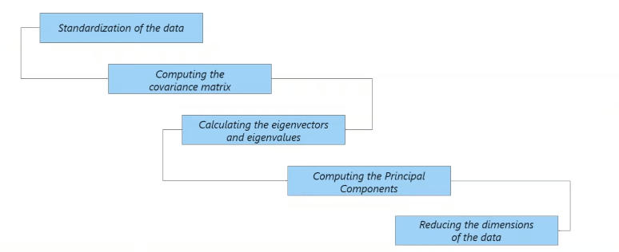

1. **Standardization of data**

*Scaling your data in such a way that all the variables and their values lie within a similar range.* By standardizing, we find the *zero mean* of each column, by subtracting the mean from each row for every column in our dataset.

Next, we divide through by the *standard deviation* to have a specific range of numbers.

**2. Computing the covariance matrix**

**Covariance matrix is a type of matrix that is used to represent the covariance values between pairs of elements given in a random vector. This matrix is very useful in stochastic modeling and principal component analysis.**

**Properties of Covariance matrix are:**

* **A covariance matrix is always a square matrix. This means that the number of rows of the matrix will be equal to the number of columns.**
* **The matrix is** [**symmetric**](https://www.cuemath.com/algebra/symmetric-matrix/)**. Suppose M is the covariance matrix then MT = M.**
* **It is positive semi-definite. Let u be a column vector, uT is the transpose of that vector and M be the covariance matrix then uTMu ≥ 0.**
* **All eigenvalues of the variance covariance matrix are** [**real**](https://www.cuemath.com/numbers/real-numbers/) **and non-negative.**

Find the covariance matrix of the dataset by multiplying the matrix of features by its *transpose*.

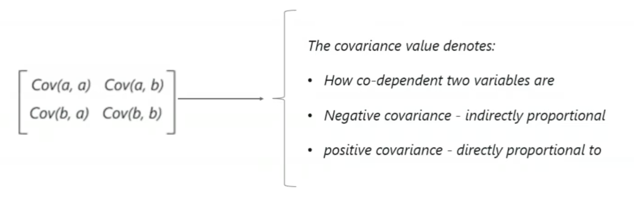

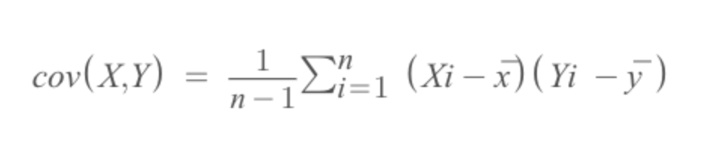

**Suppose the math and science scores of 3 students are given as follows:**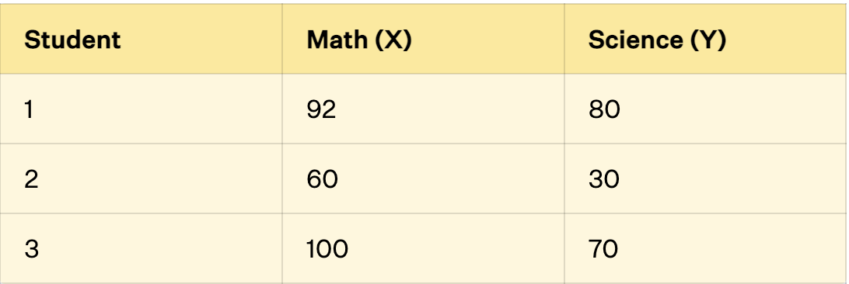

**The steps to calculate the covariance matrix for the sample are given below:**

* Step 1: Find the mean of one variable (X). This can be done by dividing the sum of all observations by the number of observations. Thus, (92 + 60 + 100) / 3 = 84
* Step 2: Subtract the mean from all observations; (92 - 84), (60 - 84), (100 - 84)
* Step 3: Take the sum of the squares of the differences obtained in the previous step. (92 - 84)2 + (60 - 84)2 + (100 - 84)2.
* Step 4: Divide this value by 1 less than the total to get the sample variance of the first variable (X). var(X) = [(92 - 84)2 + (60 - 84)2 + (100 - 84)2] / (3 - 1) = 448
* Step 5: Repeat steps 1 to 4 to find the variances of all variables. Using these steps, var(Y) = 700.
* Step 6: Choose a pair of variables (X and Y).
* Step 7: Subtract the mean of the first variable (X) from all observations; (92 - 84), (60 - 84), (100 - 84).
* Step 8: Repeat step 7 for the second variable (Y); (80 - 60), (30 - 60), (70 - 60).
* Step 9: Multiply the corresponding observations. (92 - 84)(80 - 60), (60 - 84)(30 - 60), (100 - 84)(70 - 60).
* Step 10: Add these values and divide them by (n - 1) to get the [covariance](https://www.cuemath.com/covariance-formula/). cov(x, y) = cov(y, x) = [(92 - 84)(80 - 60) + (60 - 84)(30 - 60) + (100 - 84)(70 - 60)] / (3 - 1) = 520.
* Step 11: Repeat steps 6 to 10 for different pairs of variables.
* Step 12: Now using the general formula for covariance matrix, arrange these values in matrix form. Thus, the variance covariance matrix for the example is given as
* [448 520

520 700]

**3. Calculating the eigenvectors and eigenvalues**

A vector is the special case of a matrix, where there is only one row or column.

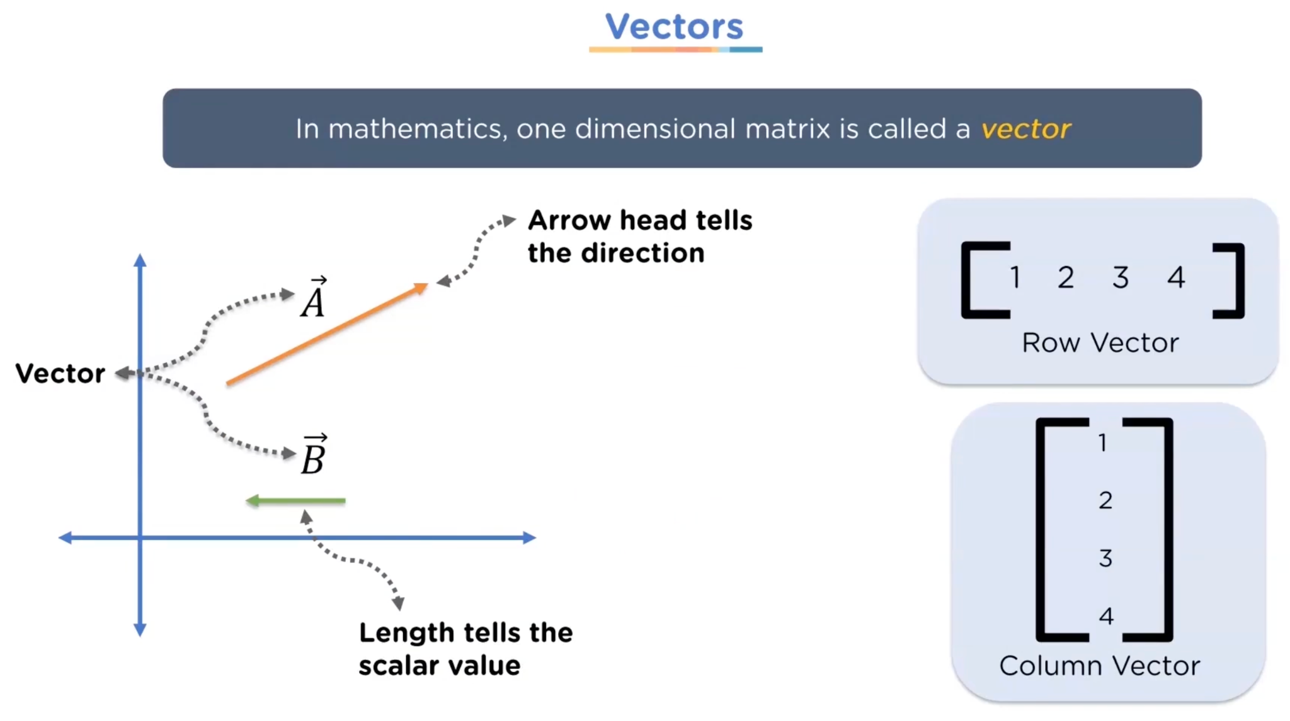

The identity matrix is a square matrix that has ones along the main diagonal and zeros elsewhere. The identity matrix has the special property that **A·I**=**I·A**=**A**.

Where, 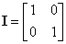

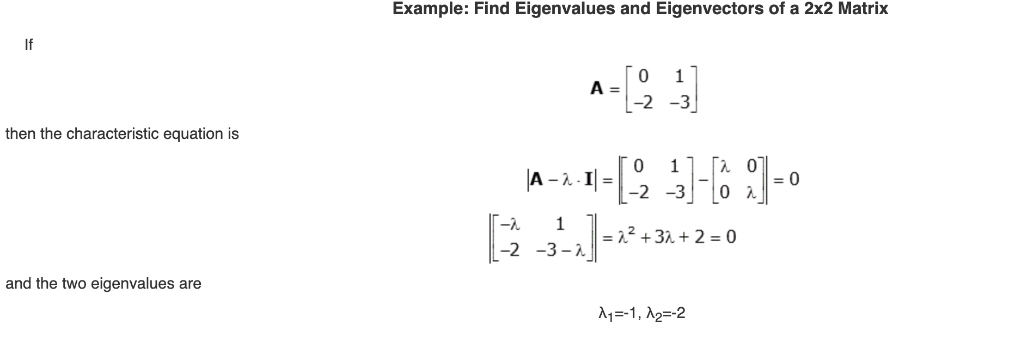

**4. Computing the Principal components**

Sort the eigenvectors by decreasing eigenvalues and choose k eigenvectors with the largest eigenvalues to form a *d × k dimensional* matrix W.

We are reducing a 3-dimensional feature space to a 2-dimensional feature subspace; we are combining the two eigenvectors with the highest eigenvalues to construct our *d×k* dimensional eigenvector matrix W.

**5. Reducing the dimensions of the data**

Use this *d × k eigenvector matrix* to transform the samples onto the new subspace.

We use matrix *W* that we just computed in the previous step to transform our samples onto the new subspace via the equation *y = W′ × x* where *W′* is the *transpose* of the matrix *W.*

**Project Flow_Chart:**

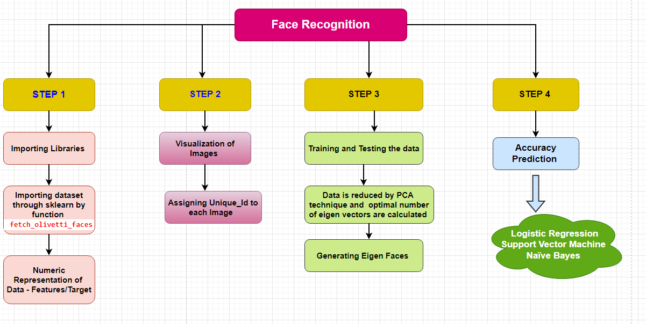

**Step1 : Importing Libraries.**

Here, we are importing important libraries and functions required for our project execution and using the function fetch_olivetti_faces() loading the dataset from scikit learn documentary. 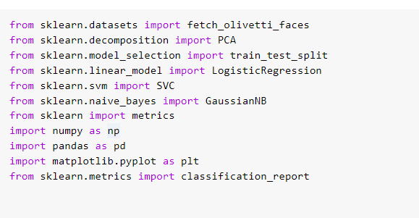

We are then defining two input variables “features” and “targets” in which features are the images of 40 people and each person has 10 images and targets are nothing but integer face ids of those 40 people(0-39). Dimensions are 64*64 pixels(4096).

Features consist of normalized values between 0-1 and so we are going to store pixel intensities in 1D subarray and 4096 values of the given image of the person in the database.

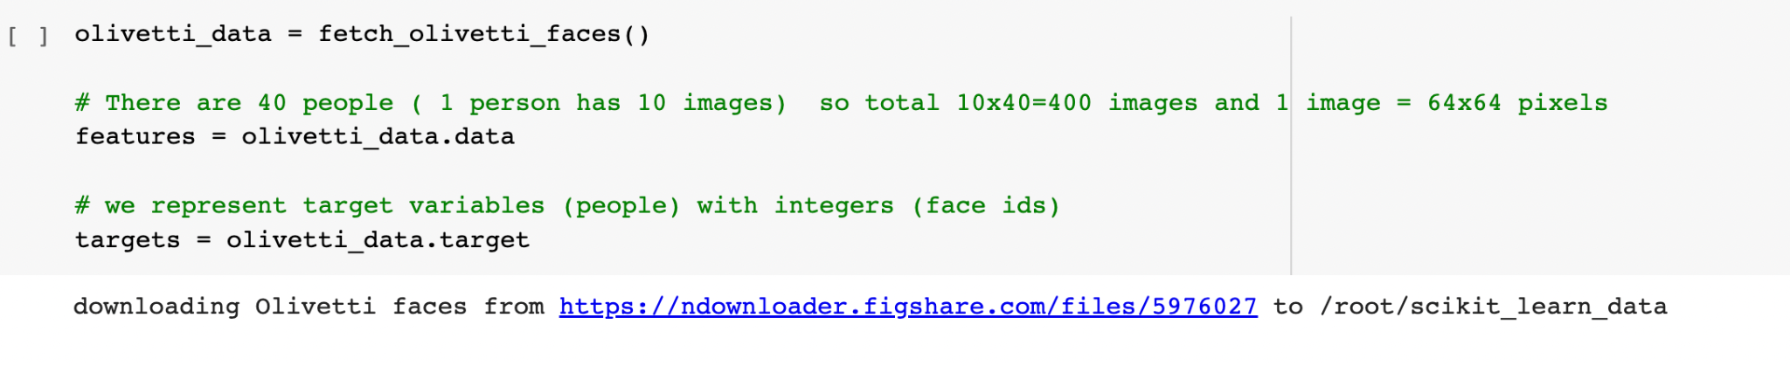

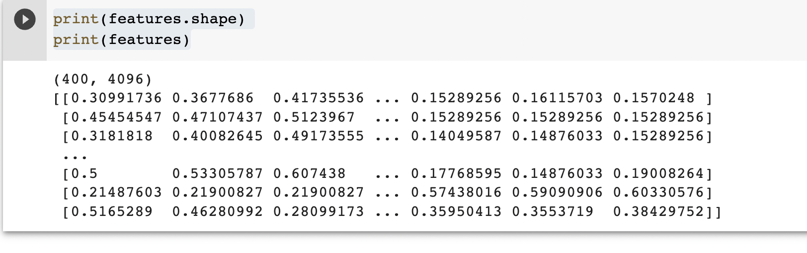

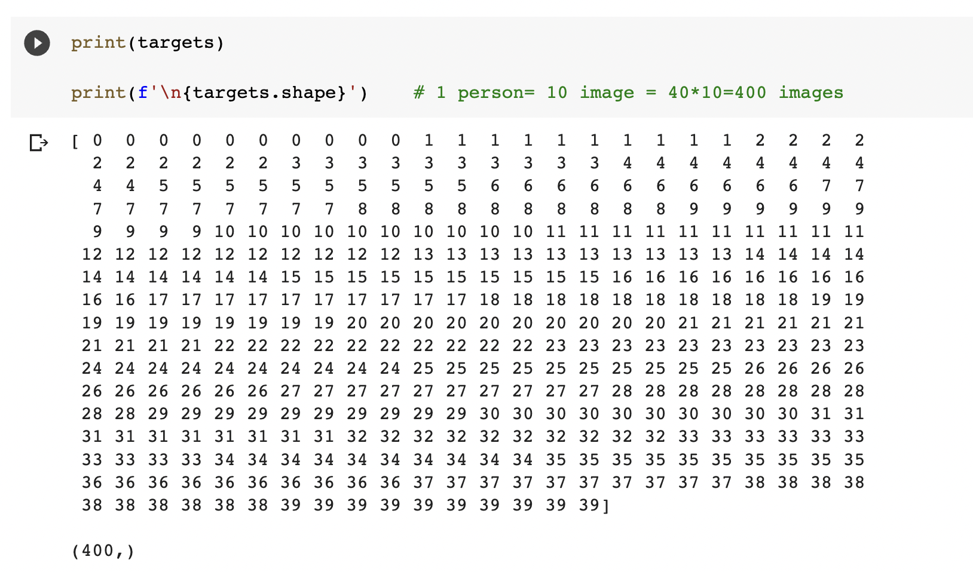

**Step2: Visualization of input and output variables**

**Graphical representation of images:**

In this step,we are constructing subplots with the P plots and creating empty arrays (place holders for the images) for images we are going to display. Then we have used flatten function which results in a one dimensional array with 40 images.

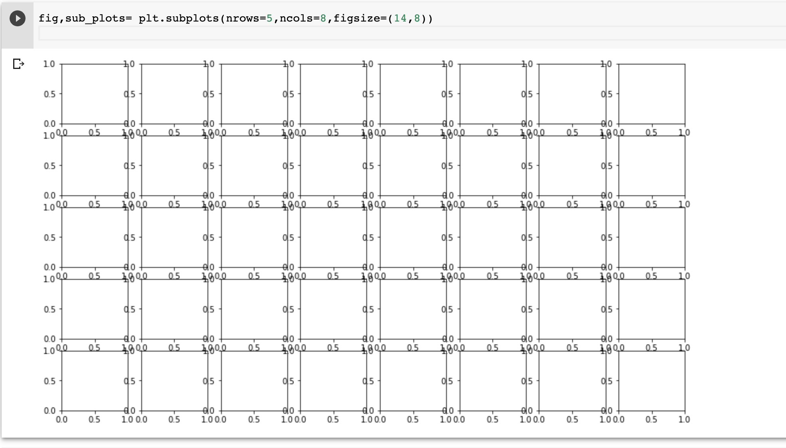

We are assigning unique names/ ids to every image as shown in below picture:

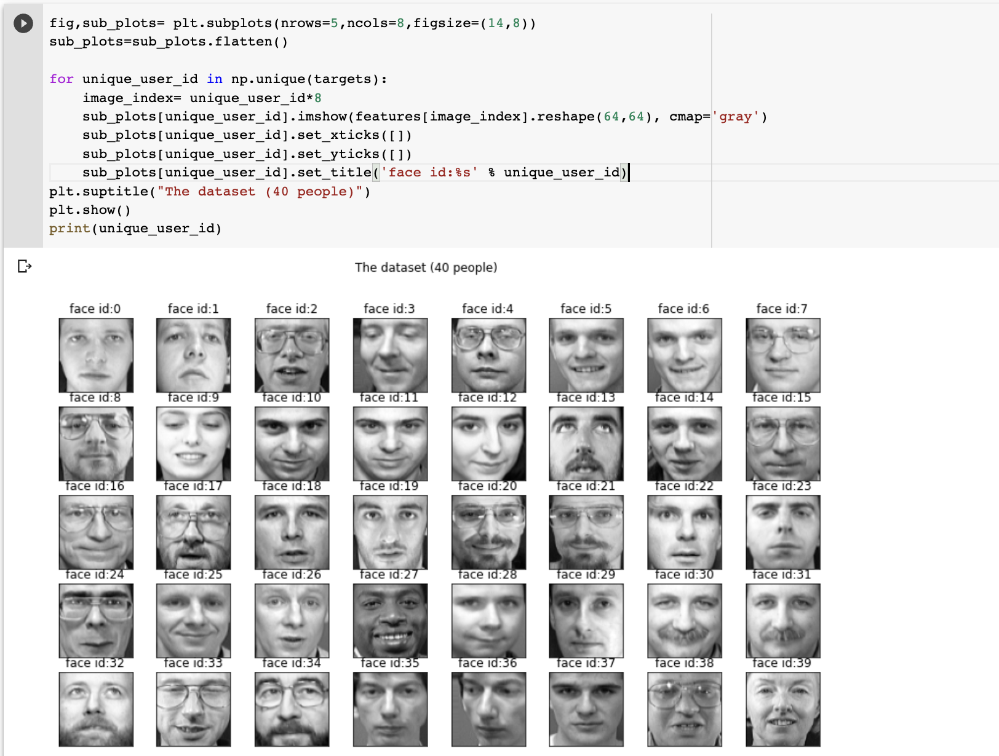

These subplot are constructed as one row and 10 columns and total figure size 18*9. We have used a loop within the range of 10 images to give a faceid number to each image. Using matplotlib function imshow() plotted gray images of 64*64 Used reshape() and cmap().

The matplotlib function imshow() **creates an image from a 2-dimensional numpy array**. The image will have one square for each element of the array. The color of each square is determined by the value of the corresponding array element and the color map used by imshow()

The person with face id 0 has 10 images with the same id as shown in below :

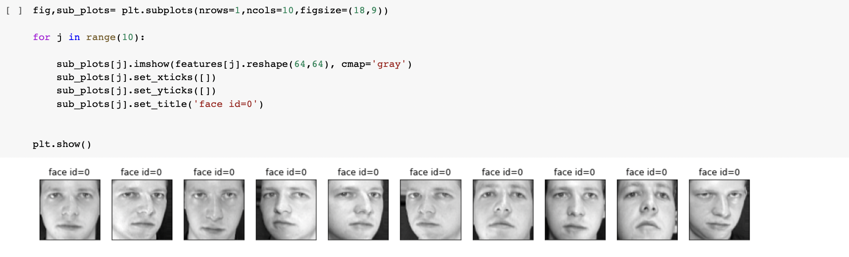

**Step3:Train and test split and reducing data using PCA**

We are training and splitting the dataset using train_test_split() from scikit learn. So we are splitting the dataset into 75% for train and 25% for test purposes.

PCA (Principal Component Analysis) is a dimensionality reduction technique that was proposed by Pearson in 1901. It uses Eigenvalues and EigenVectors to reduce dimensionality and project a training sample/data on small feature space.

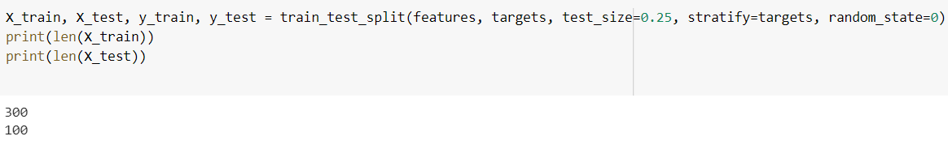

**Training Algorithm:**

* **Let’s Consider a set of *m* images of dimension *N*N* (training images).**

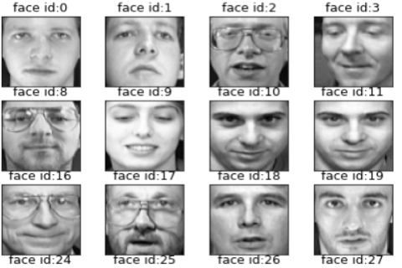

* **We first convert these images into vectors of size *N2* such that:**

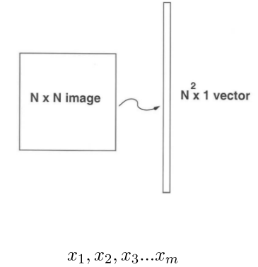

* **Now we calculate the average of all these face vectors and subtract it from each vector**

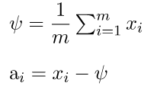

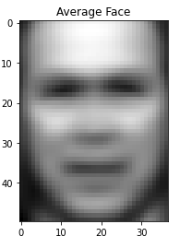

* **Now we take all face vectors so that we get a matrix of size of *N2 * M.***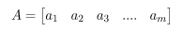
* **Now, we find Covariance matrix by multiplying *A* with *AT*. A has dimensions *N2 * M*, thus *AT* has dimensions *M * N2*. When we multiplied this gives us matrix of *N2 * N2*, which gives us *N2* eigenvectors of *N2* size which is not computationally efficient to calculate. So we calculate our covariance matrix by multiplying *AT* and *A*. This gives us *M * M* matrix which has *M (assuming M << N2)* eigenvectors of size *M*.**
* 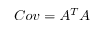
* **In this step we calculate eigenvalues and eigenvectors of the above covariance matrix using the formula below.**
* **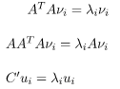  
    
    
    
  Where,**
* **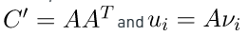  
  From the above statement It can be concluded that C’ and *C* have the same eigenvalues and their eigenvectors. Thus, the *M* eigenvalues (and eigenvectors) of covariance matrix gives the M largest eigenvalues(and eigenvectors) of C’**
* **Now we calculate Eigenvector and Eigenvalues of this reduced covariance matrix and map them into the C’ by using the formula *.***
* **Now we select the K eigenvectors of C’ corresponding to the K largest eigenvalues (where K < M). These eigenvectors have size *N2*.**
* **In this step we used the eigenvectors that we got in the previous step. We take the normalized training faces (face – average face) and represent each face vector in the linear combination of the best K eigenvectors (as shown in the diagram below).**
* 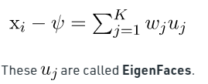

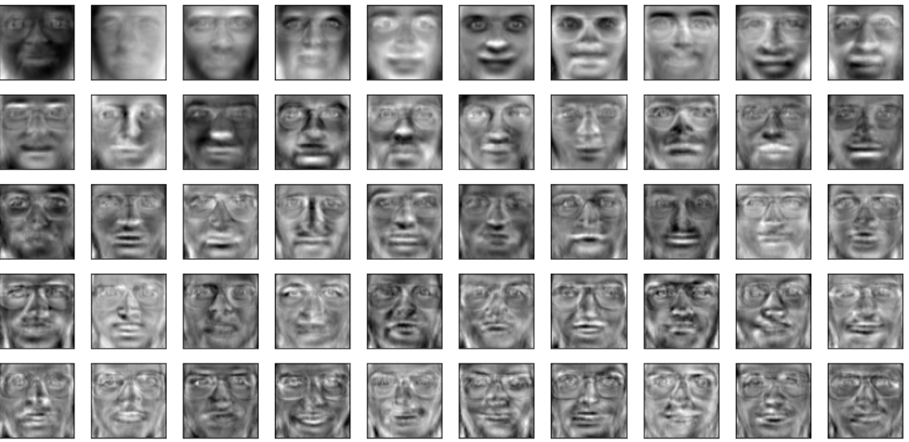

* **In this step, we take the coefficient of eigenfaces and represent the training faces in the form of a vector of those coefficients.**

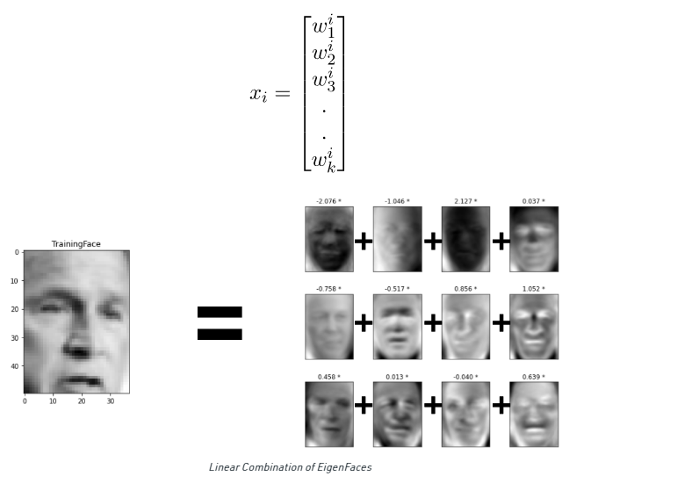

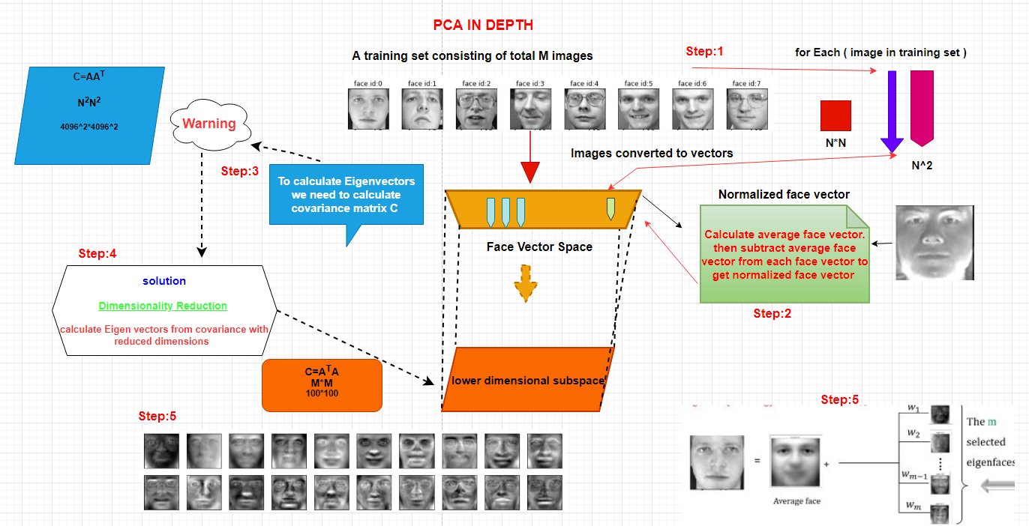

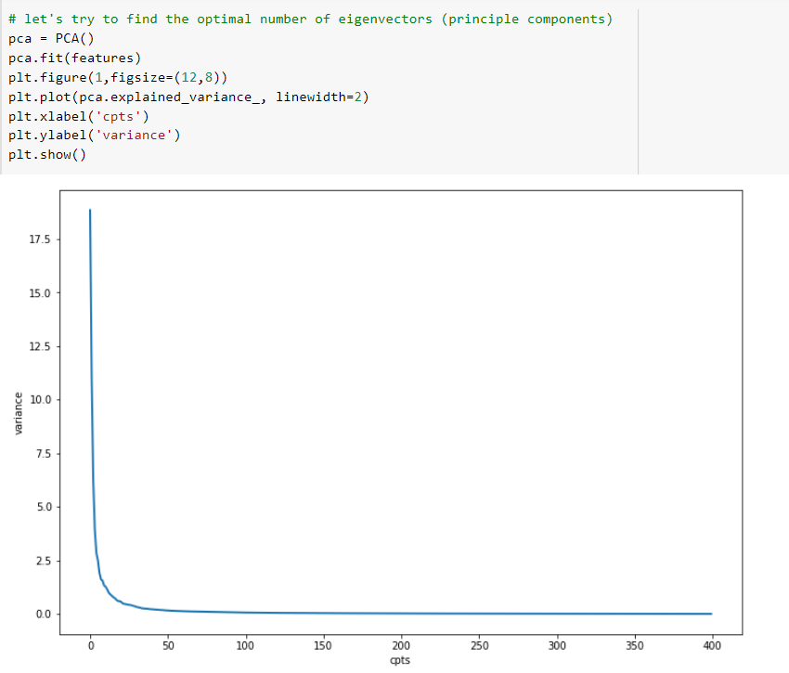

We see that 100 components account for just over 92% of the variance. That would lead us to believe that using these 100 components, we would recover most of the essential characteristics of the data. To make this more concrete, we can compare the input images with the images reconstructed from these 100 components.

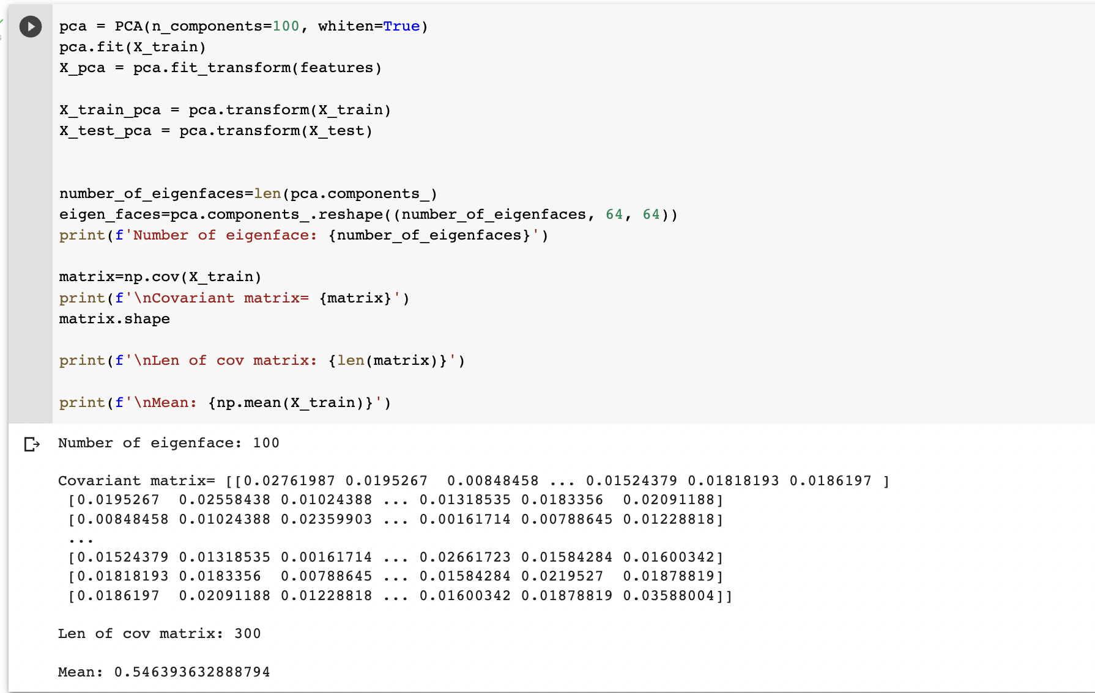

**Step 4: Generating Eigen faces**

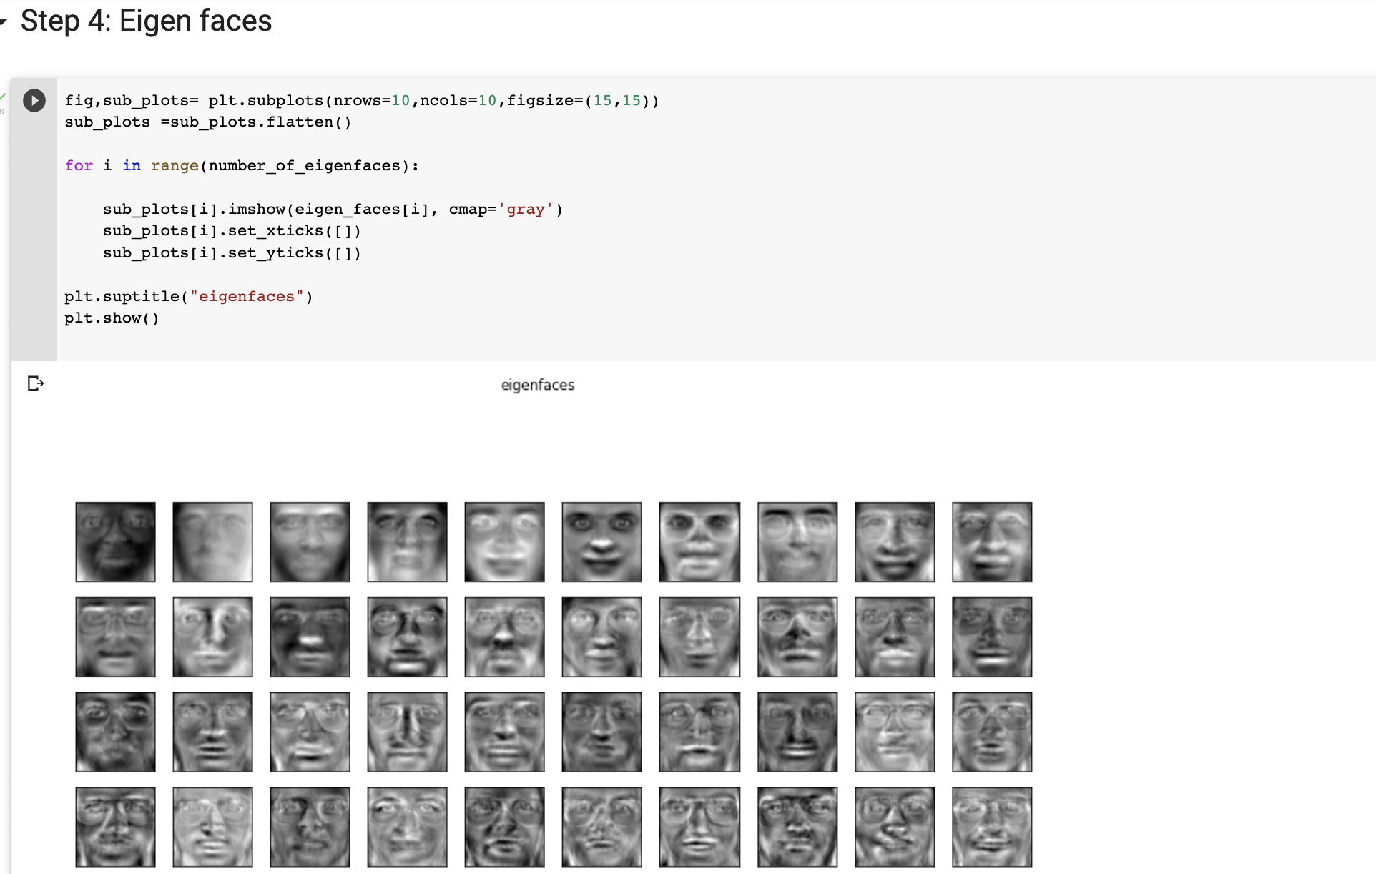

**Testing/Detection Algorithm :**

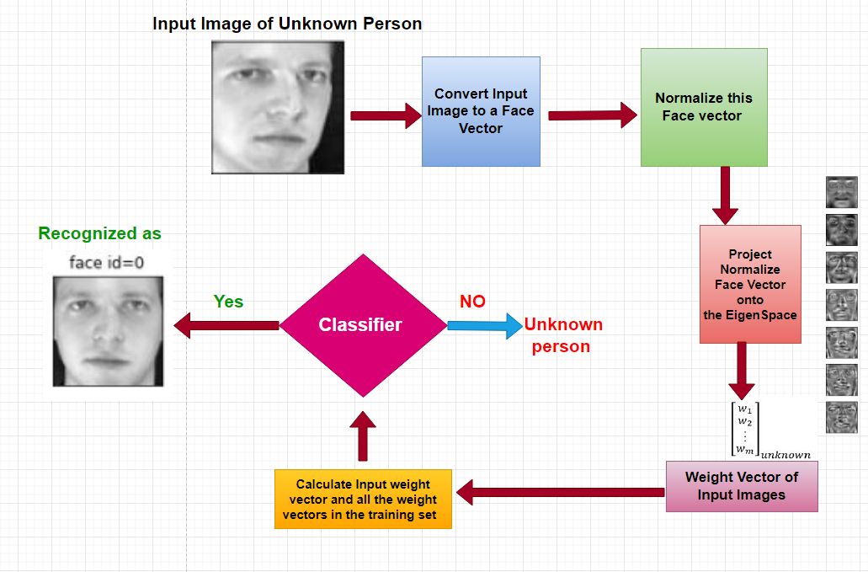

* **Given an unknown face *y*, we need to first preprocess the face to make it centered in the image and have the same dimensions as the training face**
* **Now, we subtract the face from the average face .**
* **Now, we project the normalized vector into eigenspace to obtain the linear combination of eigenfaces.**

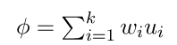

* **From the above projection, we generate the vector of the coefficient such that**

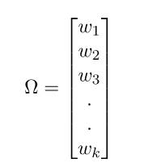

* **We take the vector generated in the above step and subtract it from the training image to get the minimum distance between the training vectors and testing vectors**

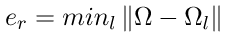

* **If this is below tolerance level *Tr*, then it is recognised with *l* face from the training image, else the face is not matched from any faces in the training set.**

**Step5: Accuracy :**

Accuracy is calculated by training the model with the Important Classification models of supervised learning that is Logistics Regression, support vector machine, Naive bayes classifier using the classifier fit model using the metric.accuracy_score function.A maximal accuracy of 90% is obtained on dataset even though the images are relatively well positioned and illuminated.

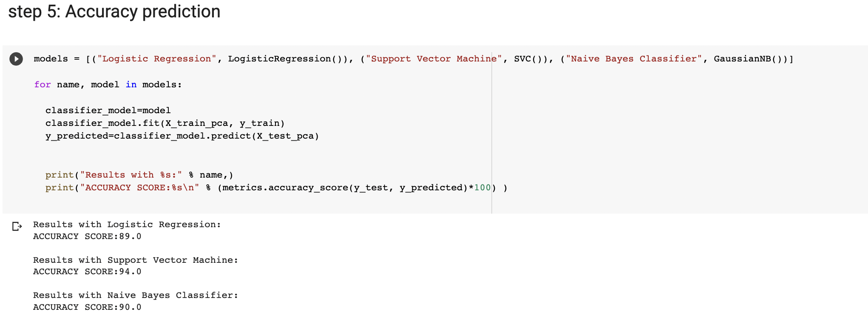

**Confusion Matrix**

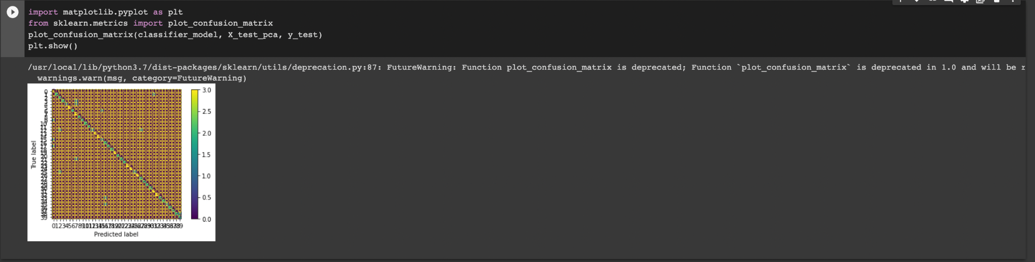

**A confusion matrix** is a performance measurement method for Machine learning classification. It helps you to know the performance of the classification model on a set of test data so that the true values and false are known. It helps us find out how many times our model has given correct or wrong output and of what type. Hence, it is a very important tool for evaluating classification models.

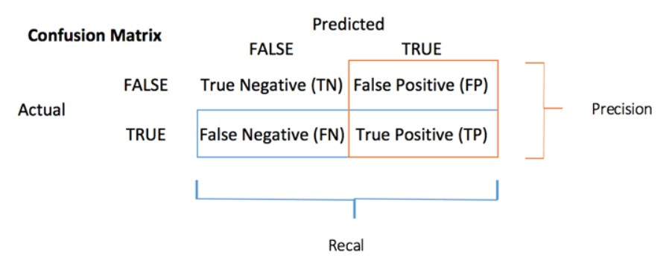

So, there are net 4 types of outcomes possible.

* TP: True Positive: Predicted values correctly predicted as actual positive
* FP: False Positive: Predicted values incorrectly predicted an actual positive. i.e., Negative values predicted as positive
* FN: False Negative: Positive values predicted as negative
* TN: True Negative: Predicted values correctly predicted as an actual negative

**We can compute the accuracy test from the confusion matrix:**

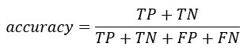

Code Implementation

from sklearn.datasets import fetch_olivetti_faces

from sklearn.decomposition import PCA

from sklearn.model_selection import train_test_split # as its important to train and test data

from sklearn.linear_model import LogisticRegression # importing linear model for logistic regression, one of the model we are using

from sklearn.svm import SVC

from sklearn.naive_bayes import GaussianNB

from sklearn import metrics # this module implements several loss, score, and utility functions to measure classification performance

import numpy as np

import pandas as pd

import matplotlib.pyplot as plt

#%matplotlib inline

olivetti_data = fetch_olivetti_faces()

# There are 40 people ( 1 person has 10 images) so total 10x40=400 images and 1 image = 64x64 pixels

features = olivetti_data.data

# we represent target variables (people) with integers (face ids)

targets = olivetti_data.target

print(features.shape)

print(features)

print(targets)

print(f'\n{targets.shape}') # 1 person= 10 image = 40*10=400 images

fig,sub_plots= plt.subplots(nrows=5,ncols=8,figsize=(14,8))

sub_plots=sub_plots.flatten()

for unique_user_id in np.unique(targets):

image_index= unique_user_id*8

sub_plots[unique_user_id].imshow(features[image_index].reshape(64,64), cmap='gray')

sub_plots[unique_user_id].set_xticks([])

sub_plots[unique_user_id].set_yticks([])

sub_plots[unique_user_id].set_title('face id:%s' % unique_user_id)

plt.suptitle("The dataset (40 people)")

plt.show()

print(unique_user_id)

fig,sub_plots= plt.subplots(nrows=1,ncols=10,figsize=(18,9))

for j in range(10):

sub_plots[j].imshow(features[j].reshape(64,64), cmap='gray')

sub_plots[j].set_xticks([])

sub_plots[j].set_yticks([])

sub_plots[j].set_title('face id=0')

plt.show()

X_train, X_test, y_train, y_test = train_test_split(features, targets, test_size=0.25, stratify=targets, random_state=0)

# let's try to find the optimal number of eigenvectors (principle components)

pca = PCA()

pca.fit(features)

plt.figure(1,figsize=(12,8))

plt.plot(pca.explained_variance_, linewidth=2)

plt.xlabel('Componenets')

plt.ylabel('Variance')

plt.show()

pca = PCA(n_components=100, whiten=True)

pca.fit(X_train)

X_pca = pca.fit_transform(features)

X_train_pca = pca.transform(X_train)

X_test_pca = pca.transform(X_test)

number_of_eigenfaces=len(pca.components_)

eigen_faces=pca.components_.reshape((number_of_eigenfaces, 64, 64))

print(f'Number of eigenface: {number_of_eigenfaces}')

matrix=np.cov(X_train)

print(f'\nCovariant matrix= {matrix}')

matrix.shape

print(f'\nLen of cov matrix: {len(matrix)}')

print(f'\nMean: {np.mean(X_train)}')

fig,sub_plots= plt.subplots(nrows=10,ncols=10,figsize=(15,15))

sub_plots =sub_plots.flatten()

for i in range(number_of_eigenfaces):

sub_plots[i].imshow(eigen_faces[i], cmap='gray')

sub_plots[i].set_xticks([])

sub_plots[i].set_yticks([])

plt.suptitle("eigenfaces")

plt.show()

models = [("Logistic Regression", LogisticRegression()), ("Support Vector Machine", SVC()), ("Naive Bayes Classifier", GaussianNB())]

for name, model in models:

classifier_model=model

classifier_model.fit(X_train_pca, y_train)

y_predicted=classifier_model.predict(X_test_pca)

print("Results with %s:" % name,)

print("ACCURACY SCORE:%s\n" % (metrics.accuracy_score(y_test, y_predicted)*100) )

**Conclusion**

**Face recognition is a both challenging and important recognition technique. Among all the biometric techniques, face recognition approach possesses one great advantage, which is its user-friendliness (or non-intrusiveness). We have compared the results of three algorithms which are Logistic regression, Support Vector Machine(SVM), and Naive-bayes to show the best fit algorithm for this face recognition technology.**

**We hope this project can provide a better understanding about face recognition, and we encourage the listeners who are interested in this topic to go to the references for more detailed study.**

**References**

* [Joseph Adewumi](https://medium.com/@dareyadewumi650?source=post_page-----10186dad0c5c--------------------------------) [Mar 26, 2019]-**Understanding the Role of Eigenvectors and Eigenvalues in PCA Dimensionality Reduction**
* Matt Brems[Published on Apr 17, 2017]- **A One-Stop Shop for Principal Component Analysis**
* Machine Learning Tutorial – All the Essential Concepts in Single Tutorial <https://data-flair.training/blogs/machine-learning-tutorial/>
* <https://medium.com/@dareyadewumi650/understanding-the-role-of-eigenvectors-and-eigenvalues-in-pca-dimensionality-reduction-10186dad0c5c>
* **Principal Component Analysis in Python | Basics of Principal Component Analysis Explained | Edureka**
* <https://www.youtube.com/c/SimplilearnOfficial>
* <http://lpsa.swarthmore.edu/BackGround/RevMat/MatrixReview.html>
* https://en.wikipedia.org/wiki/Data_set

THANK YOU!